Translit | Translat | Within Epithets, God name or Not | Provenance  (every peace of evidence) | Location  (sanctuary? and orientation) | Transcription image | Related texts transliteration | Related texts translation | Involved epithets and their gods | Involved Toponym | Notes
 |  |  |  |  |  |  |  | Gods Epithets  Referred to  Equated with | within epithets  not in epithets
jA.t
jA.wt | the mounds
 |  | None | Dendera I, 39. Base E, l.65 | Dendera, Sanctuary, East wall, Base |  | Nsw.t-bjt, Nb-tA.wj, { }, ZA-Ra, Nb-xa.w { }, [63] ji=n [64] xr=T, 1w.t-1r-wr.t, Nb.t-Jwn.t, Jr.t-Ra.  [65] Jn=f n=T ary.t, arar r jA.wt, pr aq r-Dr jb=f, aq=f m tA r srd.t wnn.t, swab=f aAy.t […]. | The-King-of-Upper-and-Lower Egypt, the-Lord-of-the-Two-Lands, { } , the-Son-of-Re, the-Lord-of-Appearance, { }, [63] comes [64] to you, Hathor-the-Great, the-Mistress-of-Dendera, the-Eye-of-Re.  [65] He brings you the ary.t-flood, which climbs up to the mounds, going out and coming in totally according to his wish, it penetrates the ground to make what exists grow, it purifies [… your] chapel. | Gods Epithets  the King Nsw.t-bjt Nb-tA.wj ZA-Ra Nb-xa.w  comes to  1w.t-1r-wr.t Nb.t-Jwn.t Jr.t-Ra  Referred to  Equated with | within epithets  not in epithets | ji.n the King n.T, should be the correct writing sequence, but the titles of the king are really long so are fronted.  the Nile is male, thus basically all the floods forms might be male.
 |  |  | ID: 00101040301_a  Dendera I, 39. Base band E, l.63-65  Location Code:  Dendera_A/A/E/B |  | 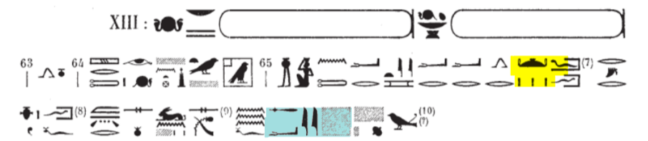
JA.t-6fn.t | the-Mound-of-Tefnut
 |  | 2nt.jt-JA.t-6fn.t (of 6fn.t) | Dendera I, 48. 4th Panel, 2nd Register E, l.30 | Dendera, Sanctuary, East wall, 4th Panel, 2nd Register |  | [29] 9d mdw jn 6fn.t, ZA.t-Ra-m-6A-rr, 5ps.t-wsr.t, 2nt.jt-JA.t-6fn.t, Nfr.t-Hr, Bnr.t-mrw.t,MH(.t)-jb-n.t-Ra-m-THHw.t | [29] Words to be spoken by Tefnut, the daughter of Ra in Tarer, the venerable and powerful one, the-Foremost-One-of-the-Mound-of-Tefnut, the one with the beautiful face and whose love is sweet, who fills the heart of Ra with joy.
 |  |  | ID: 00101040903_a  Dendera I, 46. 4th Panel, 2nd Register E, l.29-31  Location Code:  Dendera_A/A/E/4_2 |  | 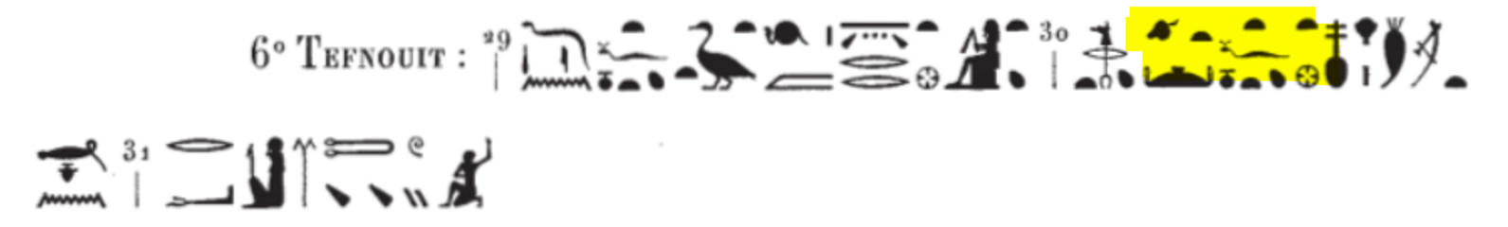
JA.t-di | Not translated now
 |  | Mw.t-nTr-xnt.j-JA.t-di | Dendera I, 29. Montant, 1st Register W, l.2 | Dendera, Sanctuary, North portal, Montant, Western side, 1st Register |  | [1] 4Htp 4xm.t.  [2] 9d mdw: mn n=k msw.t n.t sbj.w n Hm=t, Mw.t-nTr-xnt-JA.t-di | [1] (Title): Appeasing Sekhmet  [2] The speaking of words (by the King to Isis-the-Great): Receive the figure(s) of the enemies for Your Majesty, (you) the-Mother-of-the-God-the-Foremost-One-of-JA.t-di | Gods Epithets  As.t-wr.t Mw.t-nTr-xnt-JA.t-di  Referred to  4xm.t  Equated with | within epithets  JA.t-di  not in epithets
 |  |  | ID: 00101030601_a  Dendera I, 29. Montant, 1st Register W, l.1-2  Location Code:  Dendera_A/A/N_M_W/1 |  | 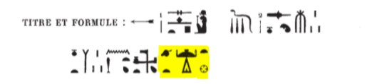 |  |  | As.t-wr.t, 00101030601
 |  | Nb.t-JA.t-di (Epithet of As.t-wr.t) | Dendera I, 7. 1st Register W, l.6 | Dendera, Sanctuary, South façade , Western side, 1st Register | 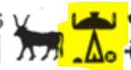 | [5] 9d mdw jn As.t-wr.t, Mw.t-nTr, [6] Nb.t-JA.t-di, 1r.j(t)-jb-Jwn.t, Nxx(.t)-m-NTr.j[7]-m-grH-Nxn-m-zS=f: [8]8i(=j) n=k 6A-mrj.j m swAS n saH=k, xAs.wt dmD(.w) Xr Tb.tj=k. | [5] The speaking of words by Isis-the-Great, the-Mother-of-the-God, [6] the-Mistress-of-JA.t-di, the-Mistress-Who-Is-in-the-Middle-of-Dendera, the-One-Who-Is-Born-Again-in-the-Sanctuary(the-Temple-of-Dendera)[7]-in-the-Night-of-the-Child-in-the-Nest: “I cause for you that the Egyptians be in praising before your figure, when the foreign countries are gathered under your sandals.” | Gods Epithets  As.t-wr.t Mw.t-nTr Nb.t-JA.t-di 1r.jt-jb-Jwn.t Nxx.t-m-NTr.j-m-grH-Nxn-m-zS=f  Referred to  ? Nxn-m-zS=f  Equated with | within epithets  JA.t-di  Jwn.t  NTr.j  zS=f  not in epithets
 |  |  | ID: 00101010501_a  Dendera I, 7. 1st Register W, l.5-8  Location Code:  Dendera_A/A_F/S_W/1 |  | 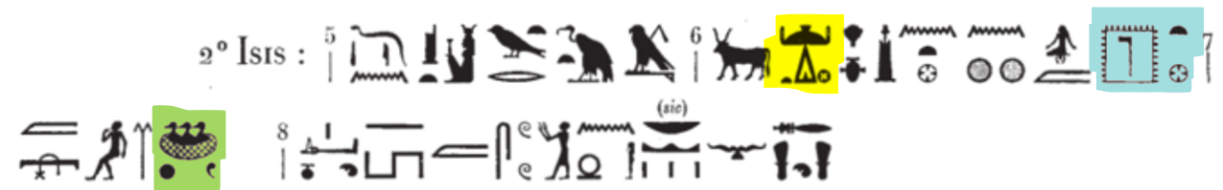
 |  |  | Dendera I, 7. 2nd Register W, l.6 | Dendera, Sanctuary, South façade , Western side, 2nd Register |  | [5] 9d mdw jn As.t-wr.t, Mw.t-nTr, [6] Nb(.t)-JA.t-di, 1r.j(t)-jb-Jwn.t, Nb.wt, Nb(.t)-Jwn.t [7] 2nt.jt-1w.t-zSS.t, ant xa.w-m-6A-rr. | [5] The speaking of words by Isis-the-Great, the-Mother-of-the-God, [6] the-Mistress-of-JA.t-di, the-Mistress-Who-Is-in-the-Middle-of-Dendera, the-Golden-One, the-Mistress-of-Dendera, [7] the-Foremost-One-of-the-Temple-of-Sistrum, the-One-Who-Is-with-Beautiful-Appearance-in-Dendera | Gods Epithets  As.t-wr.t Mw.t-nTr Nb.t-JA.t-di 1r.jt-jb-Jwn.t Nbw.t Nb.t-Jwn.t 2nt.jt-1w.t-zSS.t an.t-xa.w-m-6A-rr  Referred to  Equated with | within epithets  JA.t-di  Jwn.t  1w.t-zSS.t  6A-rr  not in epithets
 |  |  | ID: 00101010602_a  Dendera I, 7. 2nd Register W, l.5-8  Location Code:  Dendera_A/A_F/S_W/2 |  | 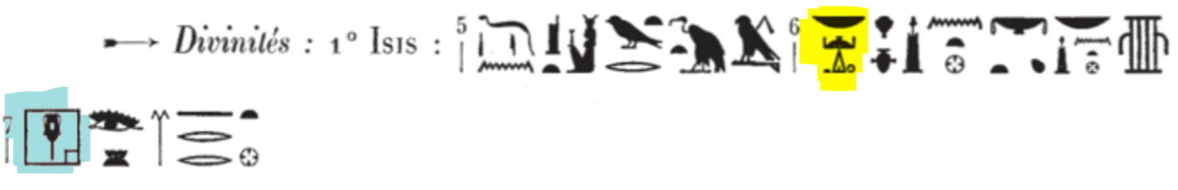
 |  |  | Dendera I, 9. Vertical Line W, l.1 | Dendera, Sanctuary, South façade , Vertical line, Western side |  | As.t-wr.t, Mw.t-nTr, Nb(.t)-JA.t-di, 1r.j(t)-jb-Jwn.t, 5ps.t-wsr.t, 2nt.jt-Pr-Sps.t, Jty.t-m-Sn.w-n.j-jtn, Nswy.t-m-p.t, Bj.tjt-m-tA, 1qA.t-m-jmn.tjt-jAb.tjt, Mw.t-nTr.jt-n.t-Bjk-n.j-nbw, 1m.t-Nsw.t-tp.jt-n.t-Wnn-nfr.w-mAa-xrw, ZA.t-n.t-bjA, 1nw.t-2AbAs, aHa 1qA Hr ns.t Hr Dd=s, Htp=s Hr mnw pn nfr jr n=s Nsw.t -bjt {}, ZA-Ra {} Hr 4.t-1r D.t | Isis-the-Great, the-Mother-of-the-God, the-Mistress-of-JA.t-di, the-Mistress-Who-Is-in-the-Middle-of-Dendera, the-Noble-and-Powerful-One, the-Foremost-One-of-the-House-of-the-Noble-One, the-Ruler-in-the-Circle-of-the-Solar-Disc, the-(Upper-Egyptian-)Queen-of-the-Heaven, the-(Lower-Egyptian-)Queen-of-the-Land, the-Ruler-in-the-West-and-in-the-East, the-Divine-Mother-of-the-Golden-Falcon, the-First-Royal-Wife-of-Onnophris-the-Justified-One, the-Daughter-of-the-Heaven, the-Sovereign-of-the-Stars, the-Ruler arises on (ascends) the throne when she is saying (it), she is pleased with this beautiful statue that the-King-of-Upper-and-Lower-Egypt {}, the-Son-of-Ra {} on the-Seat-of-Horus eternally made for her. | Gods Epithets  As.t-wr.t Mw.t-nTr Nb(.t)-JA.t-di 1r.jt-jb-Jwn.t 5ps.t-wsr.t 2nt.jt-Pr-Sps.t Jty.t-m-Sn.w-n.j-jtn Nswy.t-m-p.t Bj.tjt-m-tA 1qA.t-m-jmn.tjt-jAb.tjt Mw.t-nTr.jt-n.t-Bjk-n.j-nbw 1m.t-Nsw.t-tp.jt-n.t-Wnn-nfr.w-mAa-xrw ZA.t-n.t-bjA 1nw.t-2AbAs  Referred to  ? Bjk-n.j-nbw  ? 2AbAs  The King ? 1qA  1r None  Equated with | within epithets  JA.t-di  Jwn.t  Pr-Sps.t  not in epithets  ns.t  4.t-1r | (here Hr Dd=s, Htp=s instead of Hr Dd sHtp=s, since have to refer to the fronted epithets of the goddess Isis-the-Great, who must perform the object in the main clause)  Furthermore, Htp has the active meanign of be pleased, thus here it merely forms a circumstantial sDm=f after the main clause
 |  |  | ID: 00101010701_a  Dendera I, 9-10. Vertical line W, l.1  Location Code:  Dendera_A/A_F/S_V_W/1 |  | 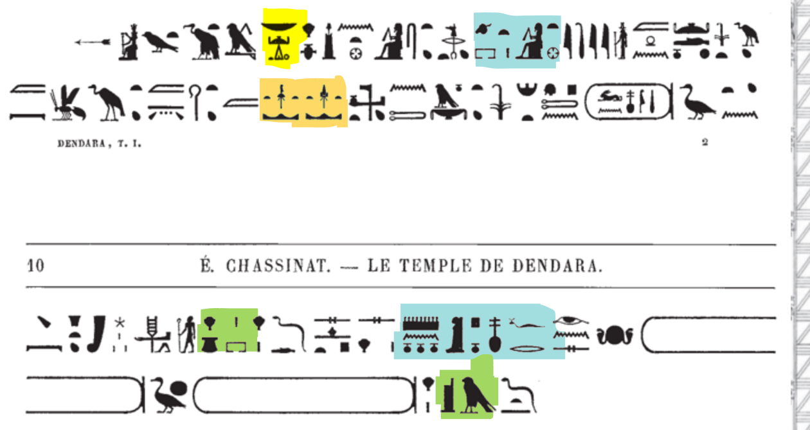
 |  |  | Dendera I, 12. Middle, Lintel, 2nd Register W, l. 6 | Dendera, Sanctuary, South façade , Middle, Lintel, Western side, 2nd Register |  | [5] 9[d mdw jn As.t-wr.t, Mw.t-nTr,Nb.t-JA.t-di,[6] 1r.jt-jb-Jwn.t].  9d mdw: […] Nbw.t, Szp.n=j sns.w m […]. | [5] The speaking of words by Isis-the-Great, the-Mother-of-the-God, the-Mistress-of-JA.t-di, [6] the-Mistress-Who-Is-in-the-Middle-of-Dendera,  The speaking of words: [... 4 cadrats ...] the-Golden-one, I received the worship in [...]. | Gods Epithets  As.t-wr.t Mw.t-nTr Nb.t-JA.t-di 1r.jt-jb-Jwn.t Nbw.t  Referred to  Equated with | within epithets  JA.t-di  Jwn.t  not in epithets | the complemented epithets in the lacuna may be taken from Dendera I, 7. 1st Register W, l.6, and Dendera I, 7. 2nd Register W, l.6, and Dendera I, 9-10. Vertical line W, l.1.  The epithets of Isis-the-Great is the same in these four registers
 |  |  | ID: 00101011101_a  Provenance: Dendera I, 12. Middle, Lintel, 2nd Register W, l.5-7  Location Code:  Dendera_A/A_F/S_M_L_W/2_L |  |  |  |  |  |  | But for some reasons, the epithets of Isis-the-Great in Dendera I, 12. Middle, Lintel, 2nd Register W, l. 6 are not the same with the above mentioned group of registers.
 |  |  | Dendera I, 14. Middle, 1st Register W, l.5 | Dendera, Sanctuary, South façade , Middle, Western side, 1st Register |  | [3] Nswy.t-bj.tjt, Wr.t-m-Jwn.t, ZA.t-Gb, Ms.t.n[-Nw.t].  [4] 9d mdw As.t-wr.t, Mw.t-nTr, [5] Nb.t-JA.t-di, 1r.jt-jb-Jwn.t,  [6] damaged. | [3] the-Queen-of-Upper-and-Lower-Egypt, the-Great-One-in-Dendera, the-Daughter-of-Geb, the-One-Who-[Nut-]Gives-Birth.  [4] The speaking of words by Isis-the-Great, the-Mother-of-the-God, [5] the-Mistress-of-JA.t-di, the-Mistress-Who-Is-in-the-Middle-of-Dendera, [6] damaged. | Gods Epithets  As.t-wr.t Nswy.t-bj.tjt Wr.t-m-Jwn.t ZA.t-Gb Ms.t.n-Nw.t Mw.t-nTr Nb.t-JA.t-di 1r.jt-jb-Jwn.t  Referred to  Gb ZA.t-Gb  Equated with | within epithets  Jwn.t  JA.t-di  not in epithets
 |  |  | ID: 00101011401_a  Provenance: Dendera I, 17. Middle, 1st Register W, l.3-6  Location Code:  Dendera_A/A_F/S_M_W/1 |  | 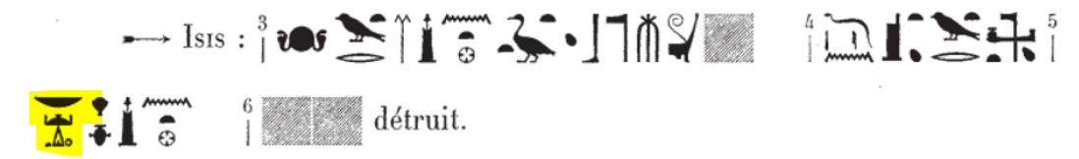 |  |  | As.t-wr.t, 00101011401
 |  |  | Dendera I, 20. Epaisseur W, l. 2 | Dendera, Sanctuary, Epaisseur/Outer Jamb, Western side |  | [2] As.t-wr.t, Mw.t-nTr, Nb.t-JA.t-di, 1r.jt-jb-Jwn.t, Nb.t-tp-rnp.t, 1nw.t-SmAj.w, Wbn(.t)-m-wp-rnp.t-r-wp-rnp.t-nfr.t. | [2] Isis-the-Great, the-Mother-of-the-God, the-Mistress-of-JA.t-di, the-Mistress-Who-Is-in-the-Middle-of-Dendera, the-Mistress-of-the-Beginning-of-the-Year, the-Mistress-of-the-Wandering-Demons, the-One-Who-Shines-on-the-Day-of-Opening-the-Year-to-Open-the-Beautiful-Year. | Gods Epithets  As.t-wr.t Mw.t-nTr Nb.t-JA.t-di 1r.jt-jb-Jwn.t Nb.t-tp-rnp.t 1nw.t-SmAj.w Wbn.t-m-wp-rnp.t-r-wp-rnp.t-nfr.t  Referred to  Equated with | within epithets  Jwn.t  JA.t-di  not in epithets
ID: 00101020201_a
Provenance:
Dendera I, 20. Epaisseur E, l. 2
Location Code:
Dendera_A/A_J/W_O/1
 |  |  | Dendera I, 22. Embrasure W, l.1 | Dendera, Sanctuary, Embrasure/Inner Jamb, Western side |  | [1] anx NTr-nfr, Jr-mnw-m-Jwn.t, BaH-6A-rr-m-nfr.w, Nsw.t-bjt, Nb-tA.wj, { }, mr.y As.t-wr.t, Mw.t-nTr, Nb.t-JA.t-di, 1r.jt-jb-Jwn.t. | [1] May the-Good-God, the-One-Who-Makes-the-Monument-in-Dendera, the-One-Who-Floods-Dendera-with-Good-Things, the-King-of-Upper-and-Lower-Egypt, the-Lord-of-the-Two-Lands, who is loved by Isis-the-Great, the-Mother-of-the-God, the-Mistress-of-JA.t-di, the-Mistress-Who-Is-in-the-Middle-of-Dendera. | Gods Epithets  the King NTr-nfr Jr-mnw-m-Jwn.t Nsw.t-bjt Nb-tA.wj  loved by  As.t-wr.t Mw.t-nTr Nb.t-JA.t-di 1r.jt-jb-Jwn.t  Referred to  Equated with | within epithets  Jwn.t  JA.t-di  not in epithets
 |  |  | ID: 00101020401_a  Provenance:  Dendera I, 22. Embrasure W, l.1  Location Code:  Dendera_A/A_J/E_I/1 |  | 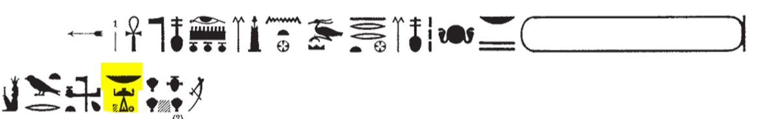
 |  |  | Dendera I, 23. Embrasure W, l.9 | Dendera, Sanctuary, Embrasure/Inner Jamb, Western side |  | [9] anx NTr-nfr, Rr.n-As.t, 2y-n.j-Ra-xnt-Jwn.t, Nsw.t-bjt, Nb-tA.wj, { }, mr.y As.t-wr.t, Mw.t-nTr, Nb.t-JA.t-di, 1r.jt-jb-Jwn.t, | [9] May the-Good-God, the-One-Whom-Isis-Raised, the child of Ra in Sunet, the-King-of-Upper-and-Lower-Egypt, the-Lord-of-the-Two-Lands, who is loved by Isis-the-Great, the-Mother-of-the-God, the-Mistress-of-JA.t-di, the-Mistress-Who-Is-in-the-Middle-of-Dendera. | Gods Epithets  the King NTr-nfr Rr.n-As.t 2y-n.j-Ra-xnt-Jwn.t Nsw.t-bjt Nb-tA.wj  loved by  As.t-wr.t Mw.t-nTr Nb.t-JA.t-di 1r.jt-jb-Jwn.t  Referred to  Ra 2y-n.j-Ra-xnt-Jwn.t  As.t Rr.n-As.t  Equated with | within epithets  Jwn.t  JA.t-di  not in epithets
 |  |  | ID: 00101020402_a  Provenance:  Dendera I, 23. Embrasure W, l.9  Location Code:  Dendera_A/A_J/E_I/1 |  | 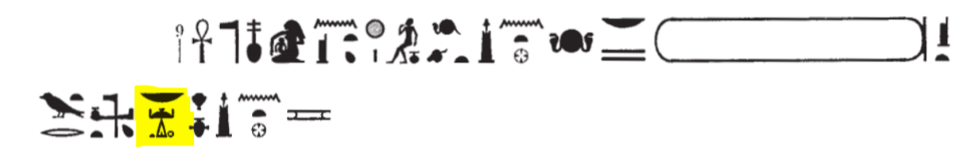
 |  |  | Dendera I, 26. Lintel, 1st Register W, l.9 | Dendera, Sanctuary, North portal, Lintel, Western side, 1st Register |  | [8] 8i=j n=k Aw.t-jb jbA ra nb, xntS Hr.w n mAA=k.  [9] 9d mdw jn As.t-wr.t, Mw.t-nTr, Nb.t-JA.t-di, [10] 1r.jt-jb-Jwn.t, 5ps.t-wsr.t, 1nw.t-nb.t-xb.t, [11] Nb.t-nwH-xnt-6A-rr, Nswy.t-m-p.t, [12] Bj.tjt-m-tA, 1qA.t, [13] 1qA.t-jA.wt-n.t-tA. | [8] I give you joy and dance every day, men rejoice for seeing you.  [9] The speaking of words by Isis-the-Great, the-Mother-of-the-God, the-Mistress-of-JA.t-di, [10] the-Mistress-Who-Is-in-the-Middle-of-Dendera, the-Noble-and-Powerful-One, [11] the-Sovereign-and-Mistress-of-Dancing, The-Mistress-of-Drunkenness-in-front-of-Dendera, the-(Upper-Egyptian-)Queen-of-the-Heaven, [12] the-(Lower-Egyptian-)Queen-of-the-Land, the-Ruler, [13] the-One-Who-Rules-the-Mounds-of-the-Land. | Gods Epithets  As.t-wr.t Mw.t-nTr Nb.t-JA.t-di 1r.jt-jb-Jwn.t 5ps.t-wsr.t 1nw.t-nb.t-xb.t Nb.t-nwH-xnt-6A-rr Nswy.t-m-p.t Bj.tjt-m-tA 1qA.t 1qA.t-jA.wt-n.t-tA  Referred to  Equated with | within epithets  JA.t-di  Jwn.t  6A-rr  jA.wt-n.t-tA  not in epithets
 |  |  | ID: 00101030201_a  Dendera I, 26. Lintel, 1st Register W, l.8-13  Location Code:  Dendera_A/A/N_L_W/1_L |  | 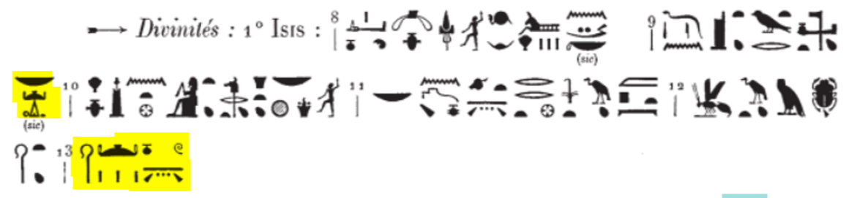
 |  |  | Dendera I, 29. Montant, 1st Register W, l.4 | Dendera, Sanctuary, North portal, Montant, Western side, 1st Register |  | [3] Nswy.t-bj.tjt, Jty.t-n.t-6A-mrj, 1qA.t, 1qA.t-Sn.w-n.j-jtn.  [4] 9d mdw jn As.t-wr.t, Mw.t-nTr, Nb.t-JA.t-di, [5] 1r.jt-jb-Jwn.t, Jr.t-Ra, Nb.t-p.t, 1nw.t-nTr.w-[6]nb.w:  [7] 8i=j n=k rky.w=k smA(.w) m sAx.t=k. | [3] The-Queen-of-Upper-and-Lower-Egypt, the-Ruler-of-Egypt, the-Ruler, the-One-Who-Rules-the-Circle-of-the-Solar-Disc.  [4] The speaking of words by Isis-the-Great, the-Mother-of-the-God, the-Mistress-of-JA.t-di, [5] the-Mistress-Who-Is-in-the-Middle-of-Dendera,  the-Eye-of-Re, the-Mistress-of-the-Heaven, the-Sovereign-of-[6]All-the-Gods:  [7]I cause for you that your enemies are slaughtered with your knife. | Gods Epithets  As.t-wr.t Nswy.t-bj.tjt Jty.t-n.t-6A-mrj 1qA.t 1qA.t-Sn.w-n.j-jtn Mw.t-nTr Nb.t-JA.t-di 1r.jt-jb-Jwn.t Jr.t-Ra Nb.t-p.t 1nw.t-nTr.w-nb.w  Referred to  Ra Jr.t-Ra  Equated with | within epithets  JA.t-di  Jwn.t  not in epithets | [7] 8i=j n=k rky.w=k smA(.w)  rdi + obj. + stative qualifying the obj. (§ 315), emphasizing state or condition
 |  |  | ID: 00101030602_a  Dendera I, 29. Montant, 1st Register W, l.3-5  Location Code:  Dendera_A/A/N_M_W/1 |  | 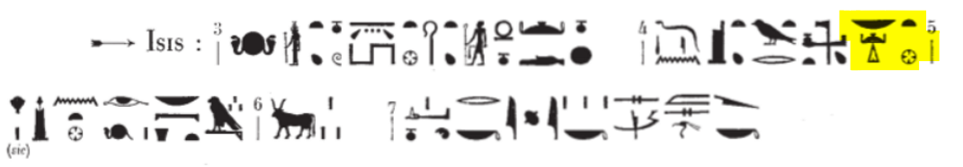
 |  | Nb.t-hy-m-hAw-JA.t-di  (Epithet of 1w.t-1r) | Dendera I, 3. 2nd Register E, l.12 | Dendera, Sanctuary, South façade , Eastern side, 2nd Register |  | (Hathor:) [12] wnn Jr.t-Ra, 2nt.jt-1w.t-zSSt, Nb(.t)-hy-m-hAw-JA.t-di, Hr xf Hr=s, Hr mAA mnw=s, Hr sbAq sSm.w=s nfr, sw m Jtn.t-m-xnt-Pr-an.t, 5ps.t-wsr.t-m-WTz.t-1r. | [12] As long as the Eye-of-Re, the-Foremost-One-of-the-Temple-of-Sistrum, the-Mistress-of-Exultation-near-JA.t-di (the Isis Temple in Dendera) is contemplating her face, seeing her statue, reflecting her beautiful image, she is the-Feminine-Solar-Disc-in-Front-of-the-House-of-the-Beauty (the Temple of Dendera), the-Noble-and-Powerful-One-in-the-Throne-of-Horus (Edfu).  [[grammar unsure, probably as long as She xxxx, She is ]] | Gods Epithets  1w.t-1r Jr.t-Ra 2nt.jt-1w.t-zSS.t Nb.t-hy-m-hAw-JA.t-di.t Jtn.t-m-xnt-Pr-an.t 5ps.t-wsr.t-m-WTz.t-1r  Referred to  Ra Jr.t-Ra  1r 5ps.t-wsr.t-m-WTz.t-1r  Equated with | within epithets  1w.t-zSS.t  JA.t-di  Pr-an.t  WTz.t-1r  not in epithets
 |  |  | ID: 00101010203_b  Dendera I, 3. 2nd Register E, l.12  Location Code:  Dendera_A/A_F/S_E/2 |  | 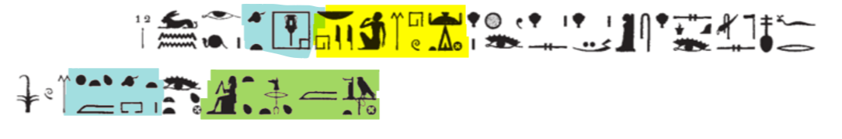
 |  | Nfr.t-Hr-xnt-JA.t-di (Epithet of 1w.t-1r-wr.t) | Dendera I, 10. Cornice, l. 1 | Dendera, Sanctuary, South façade , Middle, Cornice, Eastern side | 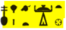 | Eastern side:  anx 1w.t-1r-wr.t, Nb.t-Jwn.t, Jr.t-Ra, Nb(.t)-p.t, 1nw.t-nTr.w-nb.w, Nb.tj-rxy.t-xnt-6A-n.j-Jtm.w, Nfr(.t)-Hr-xnt-JA.t-di. | Eastern side:  May Hathor-the-Great, the-Mistress-of-Dendera, the-Eye-of-Ra, the-Mistress-of-the-Heaven, the-Sovereign-of-All-the-Gods, the-Two-Mistresses-of-the-Plebeians-in-Front-of-the-Land-of-Atum, the-One-Who-Is-with-Beautiful-Face-in-Front-of-JA.t-di. | Gods Epithets  1w.t-1r-wr.t Nb.t-Jwn.t Jr.t-Ra Nb.t-p.t 1nw.t-nTr.w-nb.w Nb.tj-rxy.t-xnt-6A-n.j-Jtm.w Nfr.t-Hr-xnt-JA.t-di  Referred to  Ra Jr.t-Ra  Jtm.w Nb.tj-rxy.t-xnt-6A-n.j-Jtm.w  Equated with | within epithets  Jwn.t  6A-n.j-Jtm.w  JA.t-di  not in epithets
 |  |  | ID: 00101010801_a  Dendera I, 10. Cornice, l. 1  Location Code: Dendera_A/A_F/S_M_E/C |  | 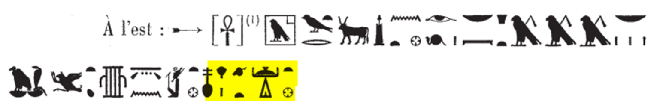
 |  |  | Dendera I, 21. Épaisseur W, l. 2-3 | Dendera, Sanctuary, Épaisseur/Outer Jamb, Western side | 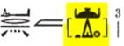  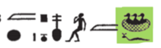 | [2] Two epithets designating Isis in separate locations, Rnp.t-rn=s-m-1w.t-kA-PtH, four epithets of goddesses in separate locations, ZA.t-Nw.t, 8i.t-r-tA-m-JA.t-di-[3]m-hrw-pn-nfr-Nxn-m-zS=f, srwD.n=f Sw.t n mAw.t r p.t, eight epithets designating Isis in separate locations, 1w.t-1r m 6A-[n.j-Jtm.w …] nb.w, Hr sA=s 1r […] | [2] Two epithets of two goddeses in separate locations, the-One-Whose-Name-in-the-Temple-of-the-Ka-of-Ptah-is-the-Year, four epithets of two goddesses in separate locations, the-Daughter-of-Nut, the-One-Who-is-Born-in-JA.t-di-[3]on-This-Beautiful-Day-of-the-Child-in-His-Nest, who has strengthened the feather (taken a flight) again to the heaven, eight epithets of two goddeses in separate locations, Hathor in the Land-[of-Atum ... 5 cadrats ...] with her son Horus [..........]. | Gods Epithets  As.t-wr.t Rnp.t-rn=s-m-1w.t-kA-PtH ZA.t-Nw.t 8i.t-r-tA-m-JA.t-di-m-hrw-pn-nfr-Nxn-m-zS=f  Referred to  PtH Rnp.t-rn=s-m-1w.t-kA-PtH  Nw.t ZA.t-Nw.t  Equated with | within epithets  1w.t-kA-PtH  JA.t-di  zS=f  not in epithets  6A-n.j-Jtm.w  not sure about whether Hathor-..is a kind of epithet or a subordinate clause. | Taking all these epithets as designation of Isis as indicated by LGG, 359 for Jmn.t-m-WAs.t.  need more justification for why these are designations of Isis instead of other goddesses be with Isis???  But at least we know that Year-is-Her-Name…, and the-Daughter-of-.. is a form of Isis-the-Great since there are no other goddesses can be designated with such epithets here.
 |  |  | ID: 00101020202_b  Provenance:  Dendera I, 21. Épaisseur E, l. 2-3  Location Code:  Dendera_A/A_J/W_O/1 |  | 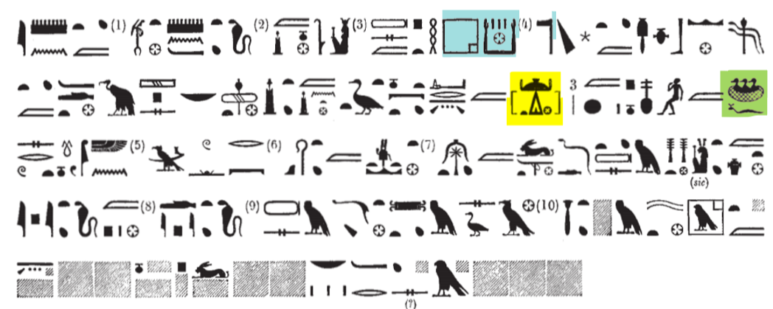
 |  | 1qA.t-jA.wt-n.t-tA(Epithet of As.t-wr.t) | Dendera I, 26. Lintel, 1st Register W, l.13 | Dendera, Sanctuary, North portal, Lintel, Western side, 1st Register | 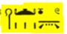 | [8] 8i=j n=k Aw.t-jb jbA ra nb, xntS Hr.w n mAA=k.  [9] 9d mdw jn As.t-wr.t, Mw.t-nTr, Nb.t-JA.t-di, [10] 1r.jt-jb-Jwn.t, 5ps.t-wsr.t, 1nw.t-nb.t-xb.t, [11] Nb.t-nwH-xnt-6A-rr, Nswy.t-m-p.t, [12] Bj.tjt-m-tA, 1qA.t, [13] 1qA.t-jA.wt-n.t-tA. | [8] I give you joy and dance every day, men rejoice for seeing you.  [9] The speaking of words by Isis-the-Great, the-Mother-of-the-God, the-Mistress-of-JA.t-di, [10] the-Mistress-Who-Is-in-the-Middle-of-Dendera, the-Noble-and-Powerful-One, [11] the-Sovereign-and-Mistress-of-Dancing, The-Mistress-of-Drunkenness-in-front-of-Dendera, the-(Upper-Egyptian-)Queen-of-the-Heaven, [12] the-(Lower-Egyptian-)Queen-of-the-Land, the-Ruler, [13] the-One-Who-Rules-the-Mounds-of-the-Land. | Gods Epithets  As.t-wr.t Mw.t-nTr Nb.t-JA.t-di 1r.jt-jb-Jwn.t 5ps.t-wsr.t 1nw.t-nb.t-xb.t Nb.t-nwH-xnt-6A-rr Nswy.t-m-p.t Bj.tjt-m-tA 1qA.t 1qA.t-jA.wt-n.t-tA  Referred to  Equated with | within epithets  JA.t-di  Jwn.t  6A-rr  jA.wt-n.t-tA  not in epithets
ID: 00101030201_b

Dendera I, 26. Lintel, 1st Register W, l.8-13

Location Code:
Dendera_A/A/N_L_W/1_L
 |  | 2nt.j-JA.t-di (Epithet of the King) | Dendera I, 14. Middle, 2nd Register W, l.3 | Dendera, Sanctuary, South façade , Middle, Western side, 2nd Register |  | [3] Nsw.t-bjt, ND.tj-n.t-nTr.w. Ra-Ds=f, 2nt.j -[JA.t-di.]  [4] 9d mdw jn 1r-smA-tA.wj, Nb-2A-di, [5] Ntr-aA, 1r.j-jb-Jwn.t. | [3] the-King-of-Upper-and-Lower-Egypt, the-Protector-of-the-Gods, Re-himself, the-Foremost-One-of[-JA.t-di].  [4] The speaking of words by Horus-Who-Unifies-the-Two-Lands, the-Lord-of-2A-di, [5] the-Great-God, the-One-Who-Is-in-the-Middle-of-Dendera.  [6] damaged | Gods Epithets  1r-smA-tA.wj Nsw.t-bjt ND.tj-n.t-nTr.w Ra-Ds=f 2nt.jt-JA.t-di Nb-2A-di NTr-aA 1r.j-jb-Jwn.t  Referred to  Equated with  Ra Ra-Ds=f | within epithets  JA.t-di  2A-di  Jwn.t  not in epithets
 |  |  | ID: 00101011501_a  Provenance: Dendera I, 17. Middle, 1st Register W, l.3-6  Location Code:  Dendera_A/A_F/S_M_W/2 |  | 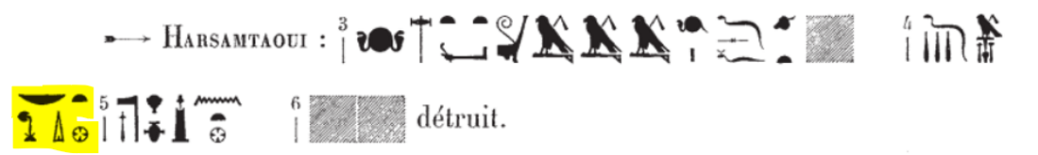
 |  |  |  |  |  |  |  | Gods Epithets  Referred to  Equated with | within epithets  not in epithets

